**Name:kip taylor**

**CS 33007 Introduction to Database System Design, Spring 2021**

**Midterm**

**Instructions:**

* *If needed you can use pen and paper. Do not forget to take a snapshot of the paper and attached to the answer script.*
* *You must submit your answer script at Blackboard (Pdf format Preferable).*

**Total Points**: 50+5Bonus **Time:** 11AM – 12:10PM

**Section 01: 10 Points**

1. What are the advantages of DBMS over traditional File Management System?

* Elimination of Data Redundancy
* Data Consistency and Integrity
* Elimination of duplicate data
* Secure - DBMS is highly secure system
* Privacy
* Better querying and reporting mechanism

1. Is the following table a Relation? If not, why?

|  |  |  |  |
| --- | --- | --- | --- |
| EmployeeNumber | Phone | Name | Name |
| 101 | 3304567898,6754326677 | Robin | John |
| 102 | 3456727891 | Mike | Haris |
| 100 | 4534457897 | Dip | Saha |
| 101 | 4568738923 | Nur | Ali |
| 102 | 3456727891 | Mike | Haris |

No , because there are two same employee number. Thus cannot be a relation due to a repeate therefore no uniqueness to them.

**Section 02: 10 Points[05+05]**

1. Write an equivalent SQL query using natural join for the following expression of relational algebra

∏ *A, r.B, C, r.D, E* (σ *r.B = s.B ˄ r.D = s.D* (*r* x *s*)))

Answer: select A, B, C, D, E from r natural join s; --- or --- select A, r.B, C, r.D, E from r natural join s;

b) Perform the right outer join on Table A and Table B. Show the result using the following table. There are some extra rows and columns

|  |  |
| --- | --- |
| Table A | Table B |
| |  |  | | --- | --- | | **ID** | **Num1** | | Mango | 8 | | Orange | 5 | | Banana | 20 | | Apple | 8 | | |  |  | | --- | --- | | **ID** | **Num2** | | Avocado | 4 | | Tomato | 6 | | Melon | 7 | | Apple | 8 | |
| .  **Table A** ***natural right outer join*** **Table B** | |
| |  |  |  |  |  | | --- | --- | --- | --- | --- | | ID | Number |  |  |  | | Mango | 8 |  |  |  | | Orange | 5 |  |  |  | | Banana | 20 |  |  |  | | Apple | 8 |  |  |  | | Avocado | 4 |  |  |  | | Tomato | 6 |  |  |  | | Melon | 7 |  |  |  | |  |  |  |  |  | |  |  |  |  |  | | |

**Section 03: 10 Points**

**Write SQL queries for the following sentences considering the given relational schema of university database**.

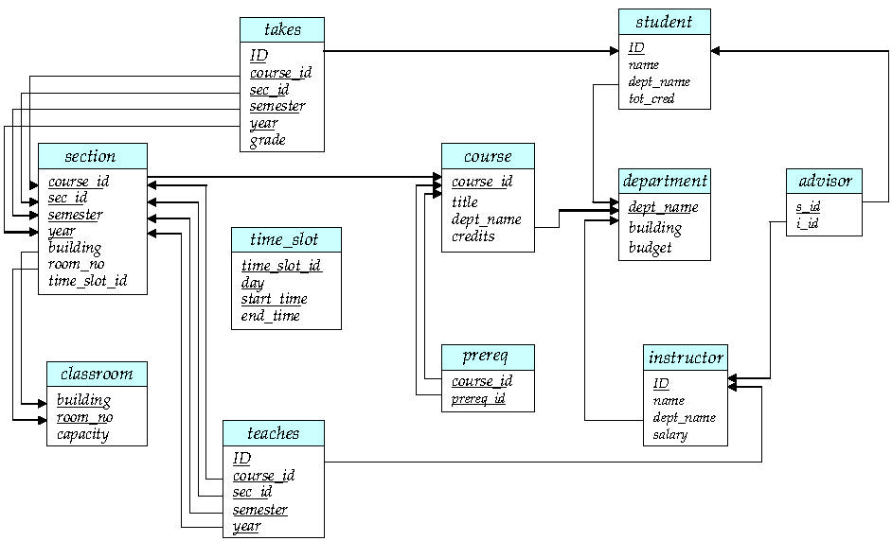

1. Suppose full name of the instructors are stored as atomic value where parts of names are  
   separated by blank space. Find all instructors who has last name “Rob”.

SELECT nane FROM Instructor WHERE name like ‘%Rob’

Make sure there is a space before rob.

1. Find the name of those departments whose total salary of the instructors is greater than  
   600000.

select dept_name, SUM(salary) as Total_salary from instructor GROUP BY dept_name having Total_salary>600000;

1. Delete courses having ID beginning with “CS”;

Answer: Delete from course where course_id like “CS%”;

**Section 04: 10 Points**

Write a SQL function that takes department name as input and increase the salary 15% only for  
the instructors whose salary is less than the average salary of the instructors of the department.

**DELIMITER //**

**CREATE procedure increment_on_salary(in dept_name varchar(30))**

**BEGIN**

**DECLARE avg_salary float;**

**SELECT AVG(salary) into avg_salary from instructor where instructor.dept_name = dept_name; update instructor**

**set salary = 1.15*salary where salary<avg_salary and instructor.dept_name = dept_name;**

**END //**

**DELIMITER ;**

**Section 05: 15 Points**

Suppose computer science department has three entity sets *instructors(i_id*, name, salary),  
*courses*(*course_id*, course_title, credit_hours) and reference_books(*book_id*, book_title,  
first_author).

1. Draw an ER diagram for the entity sets. Please note that each course must have at least one reference book.

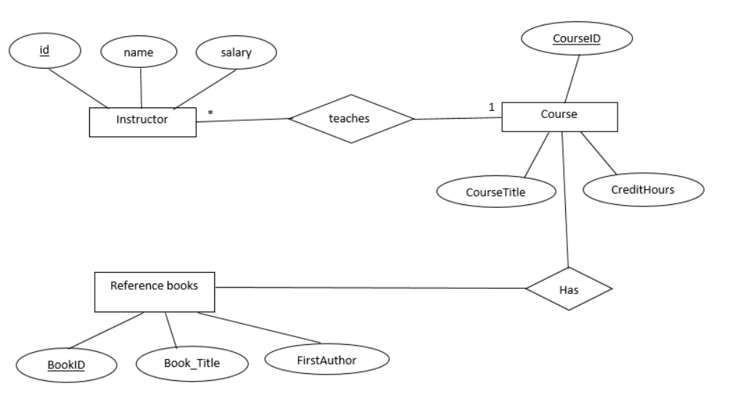

1. Convert the ER diagram to non-redundant relation schemas.

